Without Changing the Format Write Your Research Title Not Exceeding Eighteen Words

Name Surname 1
Affiliated Institution

Name Surname 2
Affiliated Institution

Abstract
You can write your own abstract in here with the framework of the rules outlined in the writing guide. The abstract should be written in a size of 10 pt., justified alignment and not exceeding 250-300 words. You can write your own abstract in here with the framework of the rules outlined in the writing guide. The abstract should be written in a size of 10 pt., justified alignment and not exceeding 250-300 words. You can write your own abstract in here with the framework of the rules outlined in the writing guide. The abstract should be written in a size of 10 pt., justified alignment and not exceeding 250-300 words. You can write your own abstract in here with the framework of the rules outlined in the writing guide. The abstract should be written in a size of 10 pt., justified alignment and not exceeding 250-300 words. You can write your own abstract in here with the framework of the rules outlined in the writing guide. The abstract should be written in a size of 10 pt., justified alignment and not exceeding 250-300 words. You can write your own abstract in here with the framework of the rules outlined in the writing guide. The abstract should be written in a size of 10 pt., justified alignment and not exceeding 250-300 words. You can write your own abstract in here with the framework of the rules outlined in the writing guide. The abstract should be written in a size of 10 pt., justified alignment and not exceeding 250-300 words.
Keywords: The number of keywords must be between 3 and 5 and should be written in lowercase letters. Separate the keywords with a comma (,).

Introduction (1. Level Title Style)
You can write the Introduction section of your study here with the framework of the rules outlined in the writing guide in “Times New Roman” font type, in a size of 10 pt., with single line spacing, with 0.75. Line indent for the first paragraphs and with 6 nk space after each paragraph (or by using “Normal” style from the styles section).

Literature Review (Use the 1. Level title style)
The subtitles of your study must be written within the title characteristics defined in the writing guide. You can use the 2. level title style in the template to create subtitles.
You can itemize the research questions or the hypotheses of your study. You can use Itemize style from the styles section.
You can write your first sub purpose here.
You can write your second sub purpose here.

Method (1. Level Title Style)
You can write your Method section here with the framework of the rules outlined in the writing guide. There must not be passthroughs between titles; instead of this, you have to write some explanatory statements between titles.

Research Model (2. Level Title Style)
You can write information about the research model of your study here.

Universe-Sample / Study Group (2. Level Title Style)
You can write information about Universe-Sample or Study Group of your research here. Choose the appropriate one according to your research model.

Data Collection Tools (2. Level Title Style)
You can write information about the tools you used in your data collecting process. If you used only one data collection tool, you should change the title according to that (Data Collection Tool) and give information about the tool without using subtitles. If you used multiple data collection tools, you should the information about the tools under the subtitles defining them.

The First Data Collection Tool (3. Level Title Style)
You can continue writing the information about data collection tool here.

The Second Data Collection Tool (3. Level Title Style)
You can continue writing the information about data collection tool here.

Ethical Committee Approval (2. Level Title Style)
Necessary information (date and number of the document and the university to which the ethics committee is affiliated) about the ethics committee judgmenet of the study should be given here.

Data Analysis (2. Level Title Style)
You can explain data analysis process of your study here.

Results (1. Level Title Style)
You can write the findings of your study here with the framework of the rules outlined in the writing guide. You can use 2. Level Title Style for the subtitles.

Table 1 (2. Level Title Style)
Sample Table Title
Dependent Variable | Function | Eigenvalue | Canonical Correlation | Wilks' Lambda | χ² | sd
School Type | 1 | .165 | .376 | .839 | 891.006** | 14
 | 2 | .023 | .149 | .978 | 113.679** | 6
Socioeconomic Level | 1 | .166 | .378 | .854 | 801.049** | 12
 | 2 | .004 | .059 | .996 | 18.054** | 5
Gender | 1 | .135 | .344 | .881 | 642.918** | 7
**p < 0.01

There must be one line spacing after the tables. Table numbers and titles must be in a size of 10 pt. and the data inside the table must be in a size of 9 pt. as shown in the table above. There must not be vertical lines in the tables and horizontal lines must be as few as possible.
While writing the values obtained through the analysis, two-digits must be used in decimal numbers but decimal values of significance levels (p) must be shown with three-digit numbers. Points, instead of commas, must be used in decimal numbers.
Percentages must be shown as 10% in English.

Figure 1 (2. Level Title Style)
Write the Figure Title Here
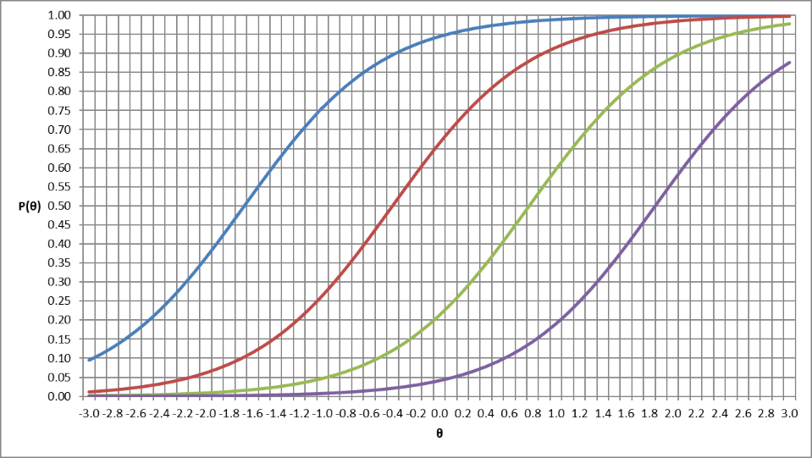

Discussion & Conclusion (1. Level Title Style)
You have to explain and discuss the findings you obtained in your study within the context of your hypotheses (purposes) and the literature. Accordingly, you have to report the results arising from these discussions. Besides, there should be some suggestions for practicians and researchers in this report. You can write all these information here.

References (1. Level Title Style)
You can write the sources you used in your study here. But be careful to be consistent with the references used in the main text. While creating the References section, you can make benefit of the samples shown in the writing guide.

Ethical Declaration and Committee Approval (1. Level Title Style)
In this research, the principles of scientific research and publication ethics were followed.
Necessary information (date and number of the document and the university to which the ethics committee is affiliated) about the ethics committee judgment of the study should be given here.

Proportion of Author’s Contribution (1. Level Title Style)
Necessary information about authors’ contributions of the article sections should be given.

Acknowledgement (if necessary) (1. Level Title Style)

If this article is a part of a master’s or doctoral dissertation or produced from a project and presented at a meeting/conference/congress, give an explanation here. If it is not that kind of a study then give first annotation with "1" to the first author, and rank the authors as such.
Corresponding Author: Title 1, Faculty, Department, E-mail: ……., ORCID: 1234-1234-1234-1234
Title 2, Faculty, Department, E-mail: ……., ORCID: 1234-1234-1234-1234

